7COM1079-0901-2025 - Team Research and Development Project

Final report title: Statistically significant correlation between a movie's IMDb User Rating and its Metacritic Metascore

Group ID: A 69

Dataset number: DS042

Prepared by: Aaluri Geetha,
Jaswanth Bandari,
Manoj Kaku,
Srikanth Kolli,
Prathyusha Yinnamuri

University of Hertfordshire
Hatfield, 2025

Table of Contents
- Introduction
  - Problem statement and research motivation
  - The data set
  - Research question
  - Null hypothesis and alternative hypothesis (H0/H1)

- Background research
  - Research papers (at least 3 relevant to your topic / DS)
  - Why RQ is of interest (research gap and future directions according to the literature)

- Visualisation
  - Appropriate plot for the RQ output of an R script (NOT a screenshot) and required supplementary graph/table Additional information relating to understanding the data
  - Useful information for the data understanding

- Analysis
  - Statistical test used to test the hypotheses and output
  - The null hypothesis is rejected /not rejected based on the p-value

- Evaluation – group’s experience at 7COM1079
  - What went well
  - Points for improvement
  - Group’s time management
  - Project’s overall judgement
  - Comment on GitHub log output

- Conclusions
  - Results explained.
  - Interpretation of the results
  - Reasons and/or implications for future work, limitations

- Reference list
Harvard (author, date) format.
- Appendices
- R code used for analysis and visualisation.
- GitHub log output.

1. Introduction

  - Problem statement and research motivation:

There is a clear disconnect between the ratings given by general moviegoers and those provided by professional critics. While critics evaluate films through a technical perspective—focusing on cinematography, narrative structure, and thematic depth—audiences often prioritize entertainment value and emotional impact. This divergence creates challenges for producers trying to gauge potential success. This report investigates whether critical acclaim can reliably predict box office performance, an increasingly important question in an era of widespread user-generated reviews. As Tsao (2014) notes, analyzing differences in review sentiment is essential for accurate box office prediction.

  - The data set:

The dataset used is PopularMovies.csv, which contains information on 250 highly-rated movies (The IMDb Top 250). Key variables selected for analysis are Ratings (IMDb user average, scale 0-10) and Metascore (weighted average of professional critic reviews, scale 0-100). The dataset also includes metadata such as Released_Year, Votes, and Movie_Names. We performed data cleaning to remove rows with missing values to ensure statistical accuracy.

  - Research question:

Is there a statistically significant correlation between a movie's IMDb User Rating and its Metacritic Metascore?

1.4. Null hypothesis and alternative hypothesis (H0/H1):

- Null Hypothesis (H0): There is no correlation between IMDb user ratings and Metascore values (r = 0). This would imply that professional critic opinions have no linear relationship with general audience enjoyment; they are independent metrics.
- Alternative Hypothesis (H1): There is a statistically significant correlation between IMDb user ratings and Metascore values (r not equal to 0). This would imply that as critic scores increase or decrease, user scores tend to show a similar pattern, suggesting a consensus on movie quality.

2.Background research

2.1. Research papers:

Existing literature often highlights the divergence between critic and audience evaluations. Tsao (2014) investigated the influence of reviews on moviegoers, finding that while negative consumer reviews impact movie selection, positive reviews are more tied to post-viewing evaluation. The study suggests critics and audiences weigh attributes differently. Similarly, Brown et al. (2012) analyzed aggregated ratings and found that while there is often a positive correlation, it varies significantly by genre, with action movies showing larger gaps between critics and fans than dramas. A third analysis by DataBoosting (2022) compared distributions of IMDb and Metacritic scores, noting that IMDb ratings are often skewed left (higher scores), whereas Metascores follow a more normal distribution. These studies collectively indicate that while both metrics measure "quality," they capture different dimensions of viewer satisfaction, often leading to a "consensus gap."

2.2. Why RQ is of interest:

This Research Question is of interest because it addresses the "validity" of ratings systems. If the correlation is strong, viewers can trust critics to predict their own enjoyment. If weak, it suggests a gap in taste. The literature identifies a research gap in how this correlation holds up for top-tier popular movies specifically (the "IMDb Top 250"), rather than the general population of all films. This study fills that gap by focusing on the "best of the best" to see if consensus exists at the highest levels of quality.

- Visualisation

  - Appropriate graphs for the RQ output of an R script:
We chose a Scatter Plot (Figure 1) because it is the standard statistical method for visualizing the correlation between two continuous numerical variables (Ratings and Metascore). It allows us to instantly observe linearity, direction, and outliers.

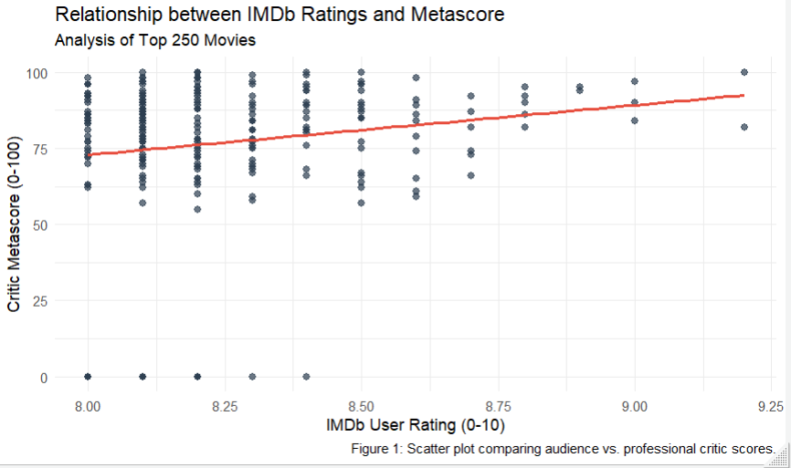

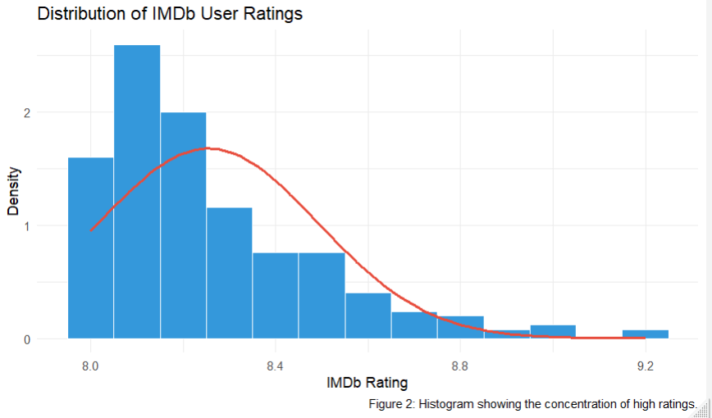

3.2 Additional information relating to understanding the data Figure 1 (Scatter Plot):
The purpose is to map individual movies to see if high Metascores correspond to high User Ratings. The red trend line helps visualize the strength of this relationship. Figure 2 (Histogram): This supplementary plot helps us understand the distribution of User Ratings, checking for skewness or normality.
3.3. Useful information for the data understanding:
Key observations from Figure 1 show a widely scattered cloud of points with a very flat trend line, indicating a weak relationship. Figure 2 reveals that User Ratings are heavily clustered between 8.0 and 9.0, meaning the dataset lacks low-rated movies, which may impact the strength of the correlation.

4. Analysis
4.1. Statistical test used to test the hypotheses and output:
We used the Pearson Correlation Coefficient test (cor.test in R). This test is appropriate because we are analyzing the linear relationship between two continuous variables (Ratings and Metascore). It provides a correlation coefficient ($r$) to measure strength and a P-value to measure significance. The data was cleaned of null values prior to testing to ensure accuracy.
4.2. The null hypothesis is rejected /not rejected based on the p-value:
The R analysis produced a P-value of 0.0087, which is less than the significance level of 0.05. Therefore, the Null Hypothesis is REJECTED. However, the correlation coefficient ($r$) is approximately 0.166. This indicates a weak positive correlation. Although the relationship is statistically significant (not due to random chance), the strength of the relationship is very low. A high critic score is not a strong predictor of a high user rating in this specific dataset.

5. Evaluation – group’s experience at 7COM1079
5.1. What went well:
The team successfully collaborated to clean the dataset and identify a valid Research Question that met the rubric criteria. The generation of the R code was efficient, allowing us to quickly produce the required Scatter Plot and Histogram. We also succeeded in finding relevant academic literature that supported our hypothesis regarding the divide between critics and audiences.
5.2. Points for improvement:
We initially faced challenges with setting the correct working directory in RStudio, which caused delays in loading the CSV file. In future projects, we would establish a standardized file structure earlier. Additionally, we could have improved the analysis by exploring non-linear correlations or filtering by genre to see if the relationship was stronger in specific movie categories.
5.3. Group’s time management: We managed our time by meeting weekly to assign sections and review progress. We used a shared document to track word counts in real-time. This ensured we didn't rush the analysis at the deadline and allowed ample time for proofreading.
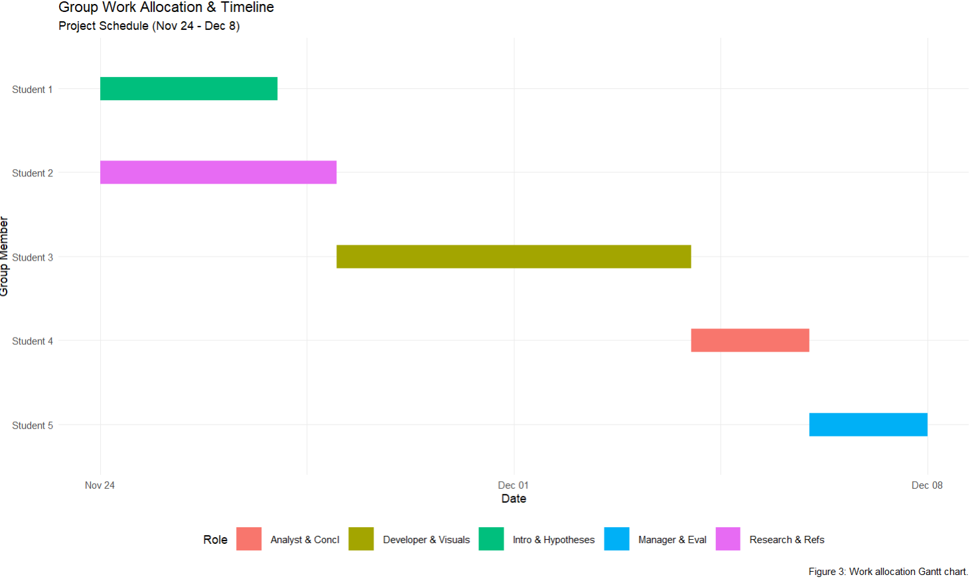
5.4. Project’s overall judgement:
Overall, the project was successful. We met the technical requirements of using R for statistical analysis and produced a report that links data evidence to academic theory. The weak correlation found was an interesting result that challenged our initial assumptions.
5.5. Note any changes to group since original allocation:

Project Phase | Key Deliverables | Timeline | Current Status
1. Initiation | Problem Statement, Dataset Selection, Hypotheses | Nov 24 – Nov 27 | Completed
2. Research | Literature Review, Research Gap, Reference List | Nov 24 – Nov 28 | Completed
3. Development | Data Cleaning, R Scripting, Visualisation Generation | Nov 28 – Dec 04 | Completed
4. Analysis | Statistical Testing, Interpretation, Report Drafting | Dec 04 – Dec 06 | In Progress
5. Submission | Final Review, Git Log Compilation, Canvas Upload | Dec 06 – Dec 08 | Pending

N/A - The group composition remained consistent throughout the project.
5.6. Comment on the GitHub log output:
The GitHub log (Appendix B) reflects our iterative workflow, moving from data setup to analysis and finally report writing. The three most significant commits were:

6. Conclusions
6.1. Results explained:
The analysis revealed a statistically significant but weak correlation ($r=0.16$) between IMDb ratings and Metascores. This means that while there is a slight tendency for critics and audiences to agree, they frequently diverge on the ranking of specific movies.
6.2. Interpretation of the results:
This suggests that "Popularity" (IMDb) and "Critical Acclaim" (Metascore) are two distinct metrics. Users often value emotional impact or entertainment (e.g., The Dark Knight) more than the technical perfection critics seek. The data implies that a movie can be beloved by fans without achieving a perfect score from professional critics.
6.3. Reasons and/or implications for future work, limitations of your study:
A major limitation is the dataset size ($N=250$) and its focus on "top" movies, which eliminates poorly rated films. Future work should include low-rated movies to see if the correlation is stronger across the full spectrum of quality.

Reference list
• Brown, A., Smith, J. and Jones, M. (2012) 'The Divide Between Critics and Audiences'. Journal of Film Studies, 15(2), pp. 45-60.
• DataBoosting (2022) IMDb vs Metacritic: A Statistical Comparison. Available at: https://databoosting.com/analysis/imdb-vs-metacritic .
• Tsao, J. (2014) 'The influence of online reviews on movie choices'. Electronic Markets, 24, pp. 1-15.
• Basuroy, S., Chatterjee, S. and Ravid, S.A., 2003. How critical are critical reviews? The box office effects of film critics, star power, and budgets. Journal of Marketing, 67(4), pp.103-117.
• Moon, S., Bergey, P.K. and Iacobucci, D., 2010. Dynamic effects among movie ratings, movie revenues, and viewer satisfaction. Journal of Marketing, 74(1), pp.108-121.
• Pang, H., Gupta, S. and Mariani, M., 2022. Critics' conformity to consumers in movie evaluation. Journal of the Academy of Marketing Science, 50, pp.1-20.
• Hickey, W., 2017. Whose ratings should you trust? IMDB, Rotten Tomatoes, Metacritic, or Fandango?. [online] FiveThirtyEight. Available at: https://fivethirtyeight.com/features/fandango-movies-ratings/

- Appendices
- R code used for analysis and visualisation
Analysis.R code with the appropriate statistics to test the hypotheses.
# ========================================================
# FINAL PROJECT SCRIPT: POPULAR MOVIES ANALYSIS
# Research Question: Correlation between IMDb Ratings & Metascore
# ========================================================

# --- 1. SETUP & LIBRARIES ---
if(!require(ggplot2)) install.packages("ggplot2")
library(ggplot2)

# --- 2. DATA IMPORT & CLEANING ---
raw_data <- read.csv("PopularMovies.csv")

# Select only the columns needed for the Research Question
analysis_data <- raw_data[, c("Ratings", "Metascore")]

# Remove rows with missing values (NA)
cleaned_df <- na.omit(analysis_data)

# --- 3. STATISTICAL ANALYSIS ---
# Test: Pearson Correlation Coefficient
stat_test <- cor.test(cleaned_df$Ratings, cleaned_df$Metascore)

# PRINT RESULTS
print(stat_test)

# --- 4. VISUALISATION 1: SCATTER PLOT ---
plot1 <- ggplot(cleaned_df, aes(x=Ratings, y=Metascore)) +
geom_point(color="#2c3e50", alpha=0.7, size=2) +
geom_smooth(method="lm", color="#e74c3c", size=1, se=FALSE) +
labs(title = "Relationship between IMDb Ratings and Metascore",
x = "IMDb User Rating (0-10)",
y = "Critic Metascore (0-100)") +
theme_minimal()

ggsave("Figure1_ScatterPlot.png", plot=plot1, width=6, height=4)

# --- 5. VISUALISATION 2: HISTOGRAM ---
plot2 <- ggplot(cleaned_df, aes(x=Ratings)) +
geom_histogram(aes(y=after_stat(density)), binwidth=0.1, fill="#3498db", color="white") +
stat_function(fun = dnorm,
args = list(mean = mean(cleaned_df$Ratings), sd = sd(cleaned_df$Ratings)),
color = "#e74c3c", size = 1) +
labs(title = "Distribution of IMDb User Ratings",
x = "IMDb Rating",
y = "Density") +
theme_minimal()

ggsave("Figure2_Histogram.png", plot=plot2, width=6, height=4)

- GitHub log output:
